- ODPOVĚZTE NA OTÁZKY – ANO, NE.
Komunikační partner nebo terapeut klade pacientovi otázky.
Je to auto? Je to okurka? Je to talíř? Je to garáž? Jsou to kalhoty?
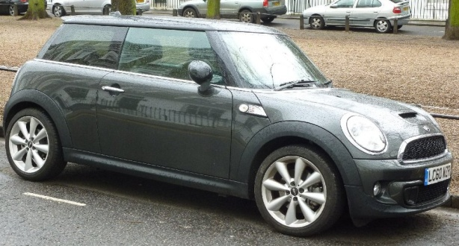
Is it a car?
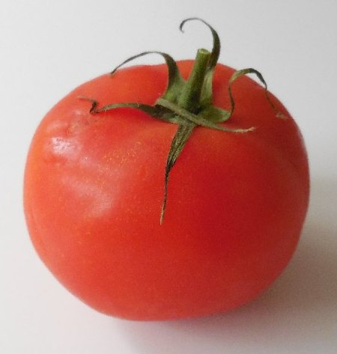

Is it a cucumber?

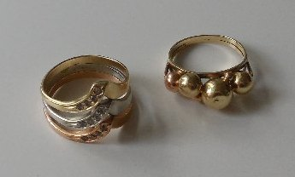
Is it a plate?
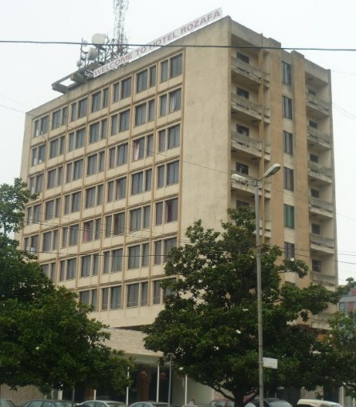

Is it a garage?
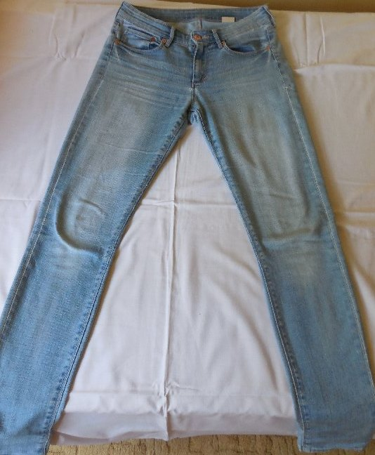

Are these trousers?

- ODPOVĚZTE NA OTÁZKY – ANO, NE.
Je to mák? Je to konev? Je to lopatka? Je to cibule? Je to koláč?
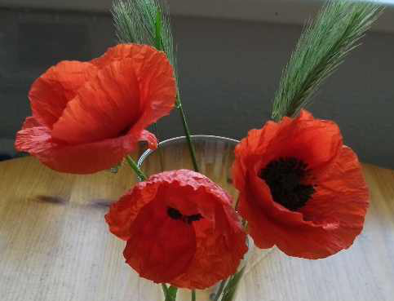
Is it a poppy?

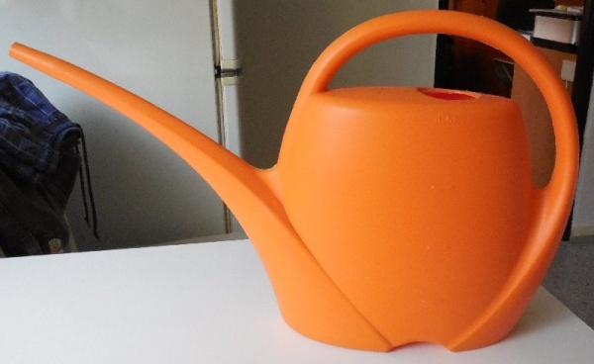
Is it a flowerpot?

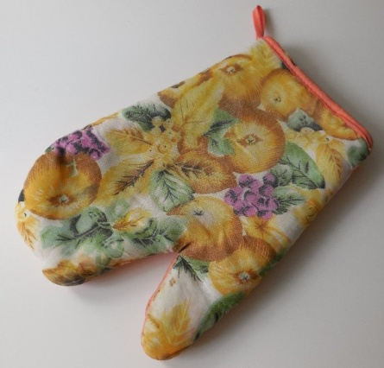

Is it a dustpan?

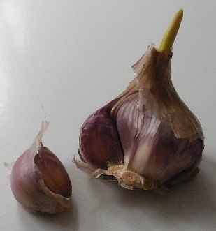

Is it an onion?
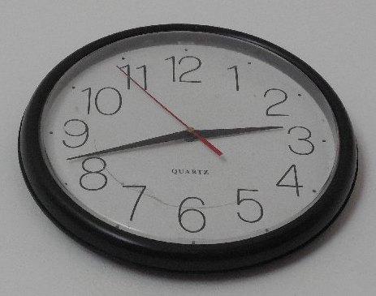

Is it a cake?

